***Old Dog, Old Tricks***

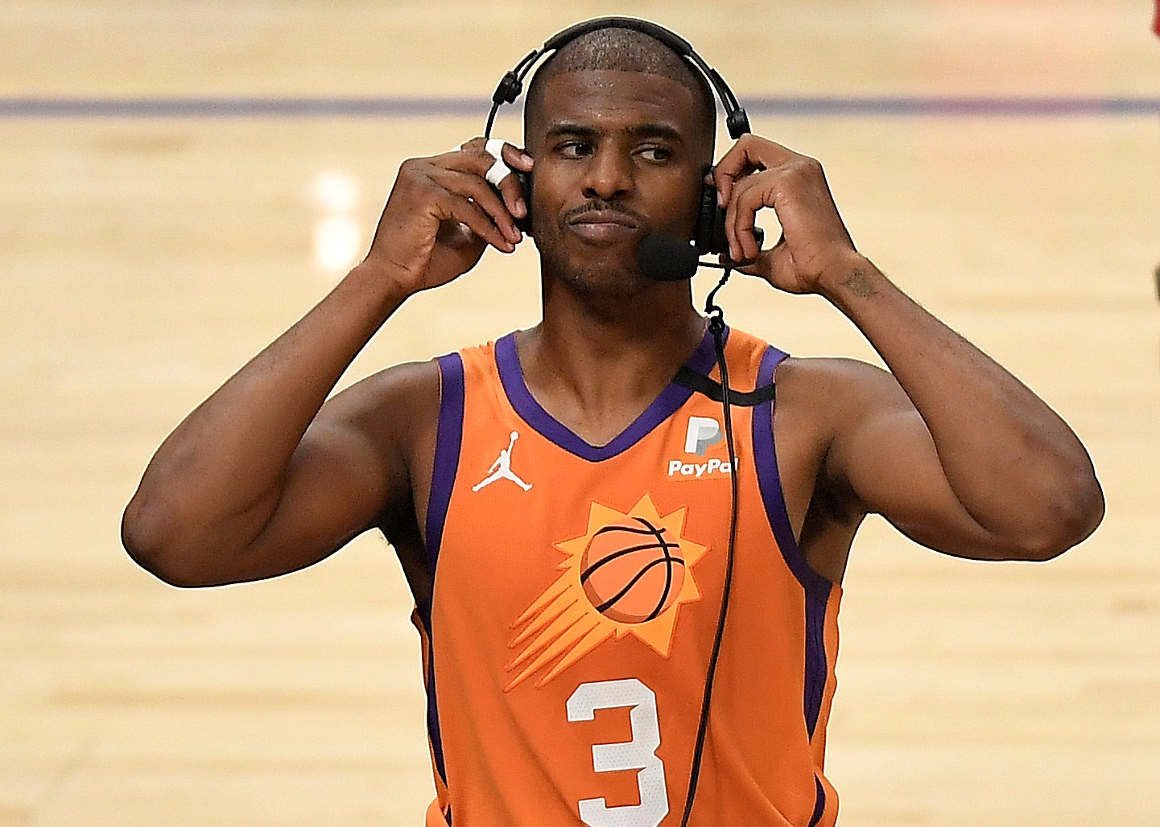36 year old Phoenix Suns point guard Chris Paul is exactly the type of player you love to have on your side, but would be insanely annoying to play against. Regardless of people’s opinions of him, many were glad to see him finally reach his first NBA Finals last year after 16 years as a pro basketball player.

The 2020-2021 season was his first with the Phoenix Suns ball club, after spending his first 6 seasons (2005-2010) with the New Orleans Hornets, his next 6 seasons with the LA Clippers (2011-2016), followed by 2 seasons with the Houston Rockets (2017,2018), and one season with the Oklahoma City Thunder (2019).

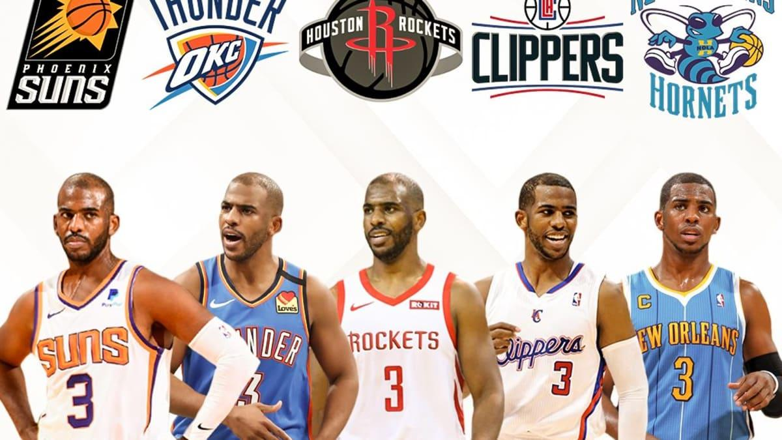

This graphic shows how each Chris Paul team experiences an increase in their winning percentage.

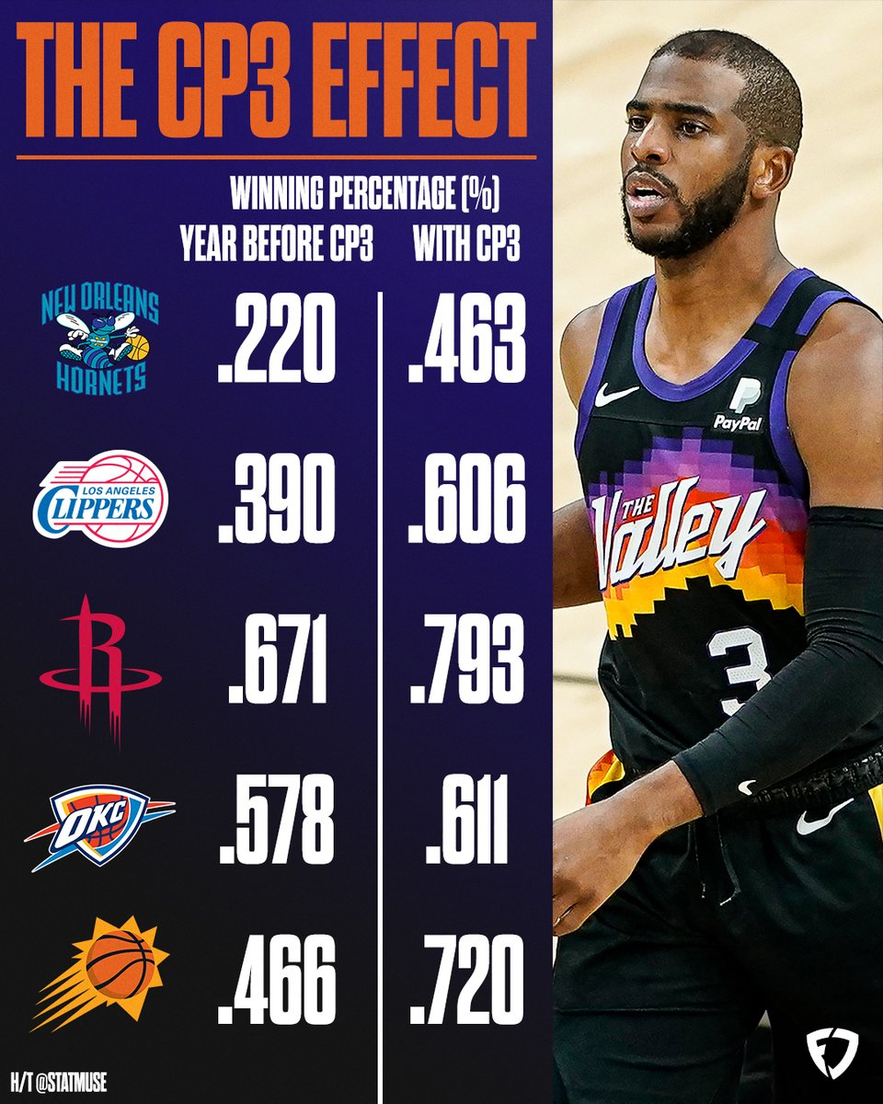

At first glance, it’s striking how a player that is smaller than almost everyone on the floor can have such monumental impact. Former Clippers teammate JJ Redick said of Paul: “He squeezes the juice out of every possession”. Meaning, when Chris Paul is added to your roster, you effectively hand over the keys to your team. As a point guard, Paul is most effective when he’s in control of every aspect of the game: The plays that are run, and the pace at which the game is played.

https://youtube.com/clip/UgkxWO-Jxgw40dTzxmVxvYvOLnWB7Fl_yXuv

The typical construction of a Chris Paul offense is as follows: Paul decides the offensive scheme while the rest of the team falls in line accordingly. This template is consistent throughout his tenure on each team.

This offensive strategy has proved to be successful, corroborated by the win percentages of his teams. After all, there is an abundance of statistical evidence to justify Paul’s approach to orchestrating a basketball team. This graphic shows Paul’s standing among the top assist men all-time.



Sitting at 3rd place all-time in assisted baskets, Paul also rarely turns the ball over to the opposing team. Among the top 10 assisters all time , Paul posts a superb assist to turnover ratio, (AST/TO). This means that per every assist that Paul makes to his teammates, he turns it over less than anyone else. ( Lakers fans wish this was Russ!)



*Paul’s Ast/TO ratio of 3.9 is the highest of all the top assisting players*

So again, this is all to say that you want Paul to have the ball in his hands. More assists + minimal turnovers = more wins.

However, despite the irrefutable positive impact of inserting Paul into the lineup of any team, he has not managed to get his hands near the elusive NBA Finals trophy until this past year.

If Paul’s presence on a roster inevitably equates to winning, why haven’t his past teams stuck with him? To answer this question, we need to dive into how his personality type meshes with other star teammates.

The answer lies in what Paul’s former teammate said about him: “He squeezes the juice out of every possession.”

Although the benefits of making CP3 the primary decision maker on any team are undeniable, the effect that this has on teammate relationships is another story.

Some high-profile players such as Blake Griffin of the LA Clippers and James Harden of the Houston Rockets have had trouble grappling with Paul over control of the offense, which lead to debilitating team camaraderie. While Paul’s insistence on control over the pace and positioning of all players on the hardwood makes a ton of sense in terms of numbers, rancorous relationships with fellow stars have caused these teams to underachieve in the past.

[James Harden Slaps Chris Paul's Hand Away in Heated Exchange of Words!](https://www.youtube.com/watch?v=M8Mmdqflr8g)

This exchange is an example of Paul’s eroding relationship with James Harden as the team moves into the postseason. Harden and Paul, both being ball-dominant players, eventually fell apart despite the success they had. Despite the fit on paper, basketball, like many other professions, can come down to a game of managing egos.

Moreover, in the 2021 Western Conference Finals, Paul poured 41 points on his former team the LA Clippers en route to his first NBA Finals. As Paul reveled in his pettiness and revenge, cameras caught a member of the Clippers saying to Paul: “And you wonder why nobody f**k with your weak a**”.

[DeMarcus Cousins to Chris Paul: “You wonder why nobody f*ck with yo weak a*s!”](https://www.youtube.com/watch?v=6MnLbk9vZVw)

Clearly, Paul’s OCD playing style and competitive nature hasn’t helped make many friends across the league.

That being said, what was it that allowed Paul to finally break through to the NBA finals this past year, and enable him to be as efficient as ever in year 16?

Perhaps it is exactly this stubborn, meticulous approach that Paul brings to the game that is responsible for the breakthrough. The same qualities which have caused CP3 to clash with high-ego players in the past, are the reasons for his elevated success in Phoenix.

[Chris Paul on Becoming A Phoenix Sun, Playing in OKC & Almost Winning it All in Houston | JJ Redick](https://www.youtube.com/watch?v=4AclDUnZ6yE)

1:04-2:01

Paul’s age and experience commands respect out of the younger talent in Phoenix, which has rendered them receptive to Paul’s advice. On a team inundated with young talent, Chris Paul’s obsessive attitude is a perfect fit for players eager to soak up the knowledge. As many people who have been in relationships can attest, your traits that are hated by one person can end up being appreciated by another person who is the right fit.

To finally reach the pinnacle that he had been chasing for 16 years, it would be natural to assume that Paul had to go through many stages of evolution in order for him to survive almost 2 decades. However, the truth is rather counterintuitive. In his long, illustrious career, Paul has been anomalously steadfast in his stylistic approach to basketball, amongst the ever changing scenery of the NBA around him.

The key to survival is said to be adaptation. Survival of the fittest, right? For Paul, the key to survival is his stubborn nature. While the rest of the NBA moves toward the “Morey-ball”– layups and three-pointers – Paul continues to assert dominance by doing the opposite – with mid-range jumpers. He remains an old dog with old tricks.

The 2010s marked a transition into a new era of the NBA. Analysts and teams have emphasized the value of the three-pointer over the mid-range two-pointer.

ESPN’s Kirk Goldsberry says in *Sprawlball* that “In the three season span between 2013-2014 and 2015-2016, the average NBA three-pointer yielded 1.07 points per shot… The average seven-footer yielded .82.” The basic theory behind the three-point craze is that the 50 percent increase in points from 2 to 3 when taking a three-pointer, is well worth the increased shot distance from the basket. Most basketball fans have heard this logic a nauseating amount of times, a point that has been shoved down our throats in modern basketball.

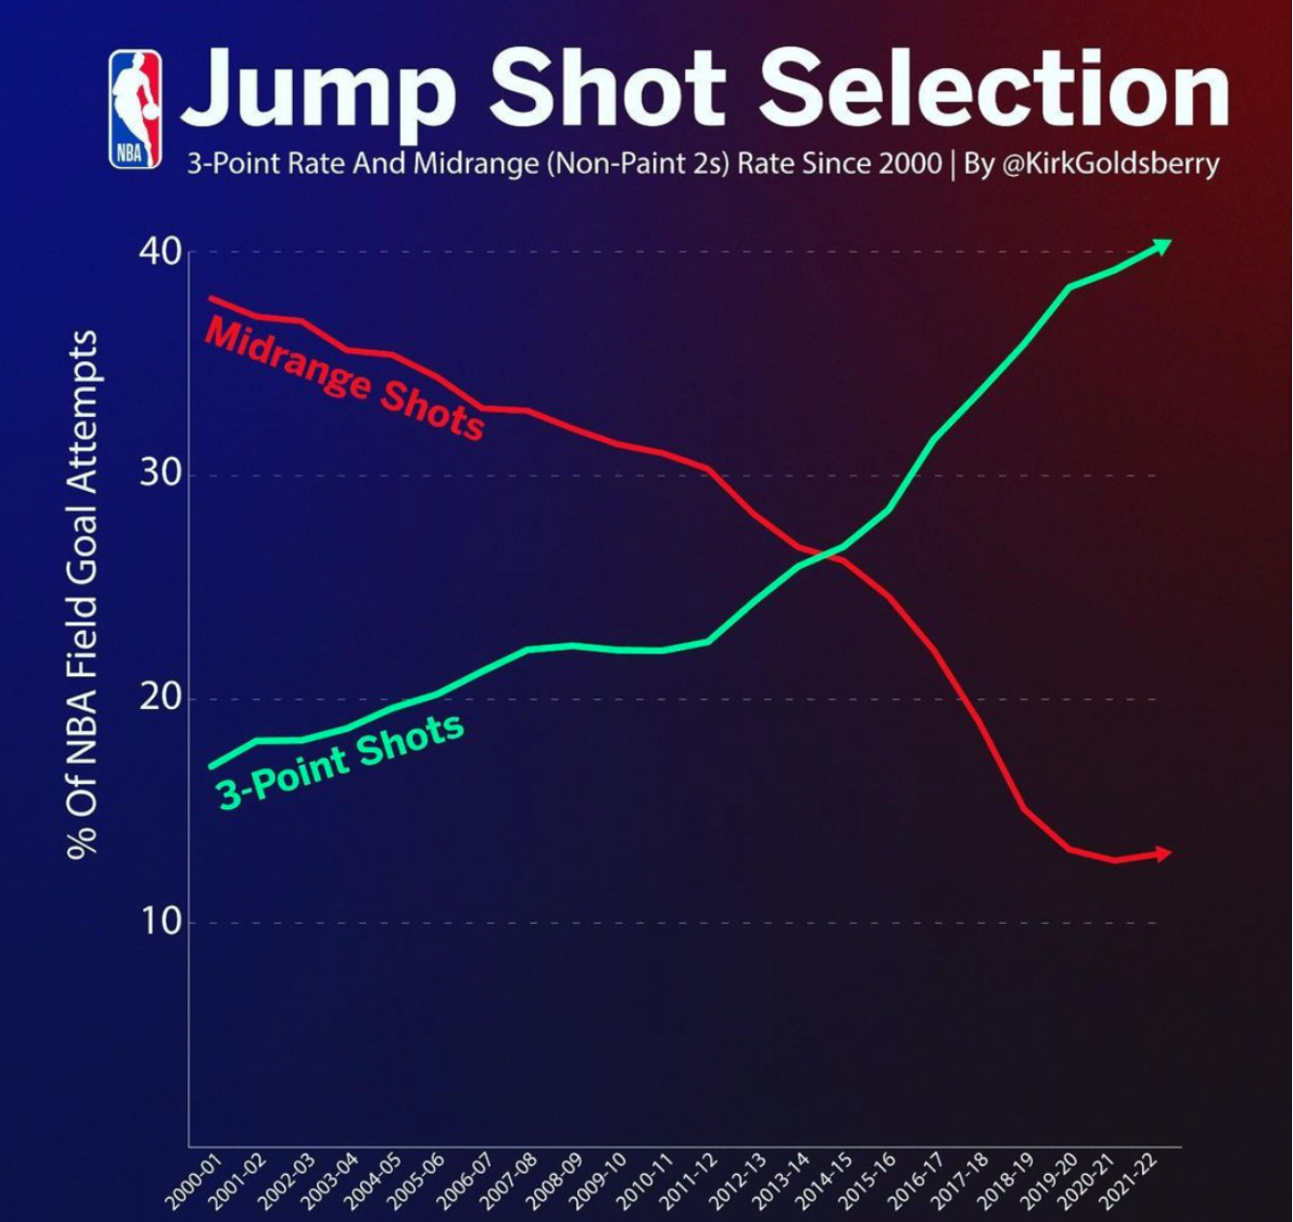

Goldsberry also states: “By 2017-2018, which was marked by Steph Curry and his Warriors winning their third championship, NBA shooters were taking more threes than mid rangers.”

In his graph, we can see that the considerable growth in three-point shots begins to take shape around 2012, when Steph Curry really breaks onto the scene.

Curry’s magical shooting from long-distance has become the cynosure of the NBA world, captivating fans and indicating how the game has transformed.

[Stephen Curry through the legs behind the back for step back three in traffic: Clippers at Warriors](https://www.youtube.com/watch?v=cP54guVj_XE)

The position that both Curry and Paul commandeer, the point guard, was originally tasked with conducting the offense and creating open shots for teammates, featuring few three-point attempts.

However, the role of the position has changed, moving away from Paul’s traditional point guard philosophy and now leaning towards the Curry way. Besides the fact that every high school benchwarmer thinks that they can drain half court look-away shots now because of Curry’s play style, Curry’s influence has had pervasive implications on the shape of the league. The following graphs show how the contours of point guard position has changed over the course of Paul’s career, evolving to be more three-point centric.



Each graph shows CP3’s frequency of 3 point shot attempts compared to the other point guards in the NBA that play the most minutes. In the 2007-2008 graph, the early stages of Paul’s career, he sits above the mean 3 point shot frequency for the point guards. However, flashing forward to 2020, Paul suddenly finds himself significantly below the mean (40 percent) 3 point attempts for point guards. In the matter of 13 years, the landscape of the point guard position has completely inverted, heavily prioritizing threes over twos: Throughout the changes around him, Paul remains relatively constant in his approach.

The 2007 graph examines fellow point guards such as Monta Ellis and Andre Miller, who are old-fashioned in the sense that they take very few 3 pointers. In 2020, the new era, it’s no surprise who leads the way in 3 point frequency: Curry at nearly 60 percent of his shots.

This revolution makes Paul essentially a basketball dinosaur, as his 3 point frequency has remained in the 20% range over the span of 13 years. He’s essentially the equivalent of that guy who still uses a flip phone (but is still just as effective!).

You might think that this unwillingness to change is just a product of Paul being older than almost every player in the NBA. To disprove this, we’ll take a look at the most notable “old” player other than Paul would be, of course, LeBron James. James has been in the NBA since 2003, two more years than Paul.



*LeBron’s 3 point attempts have increased every season since 2015.*

James’ 3 point attempts per game is now double what it once was in 2013. Unlike Chris Paul, LeBron has altered his game to adapt to his surroundings, acquiescing to the Curry philosophy.

James, being 6 feet 9 inches tall, has had to lean on the long distance shot as he ages to reduce the wear and tear on his body.

Conversely, Paul’s playing style as a 6 foot point guard has been translated to modern times without much alteration. His signature shot, the midrange jumper, is more valuable than ever now that everyone else is shooting threes.

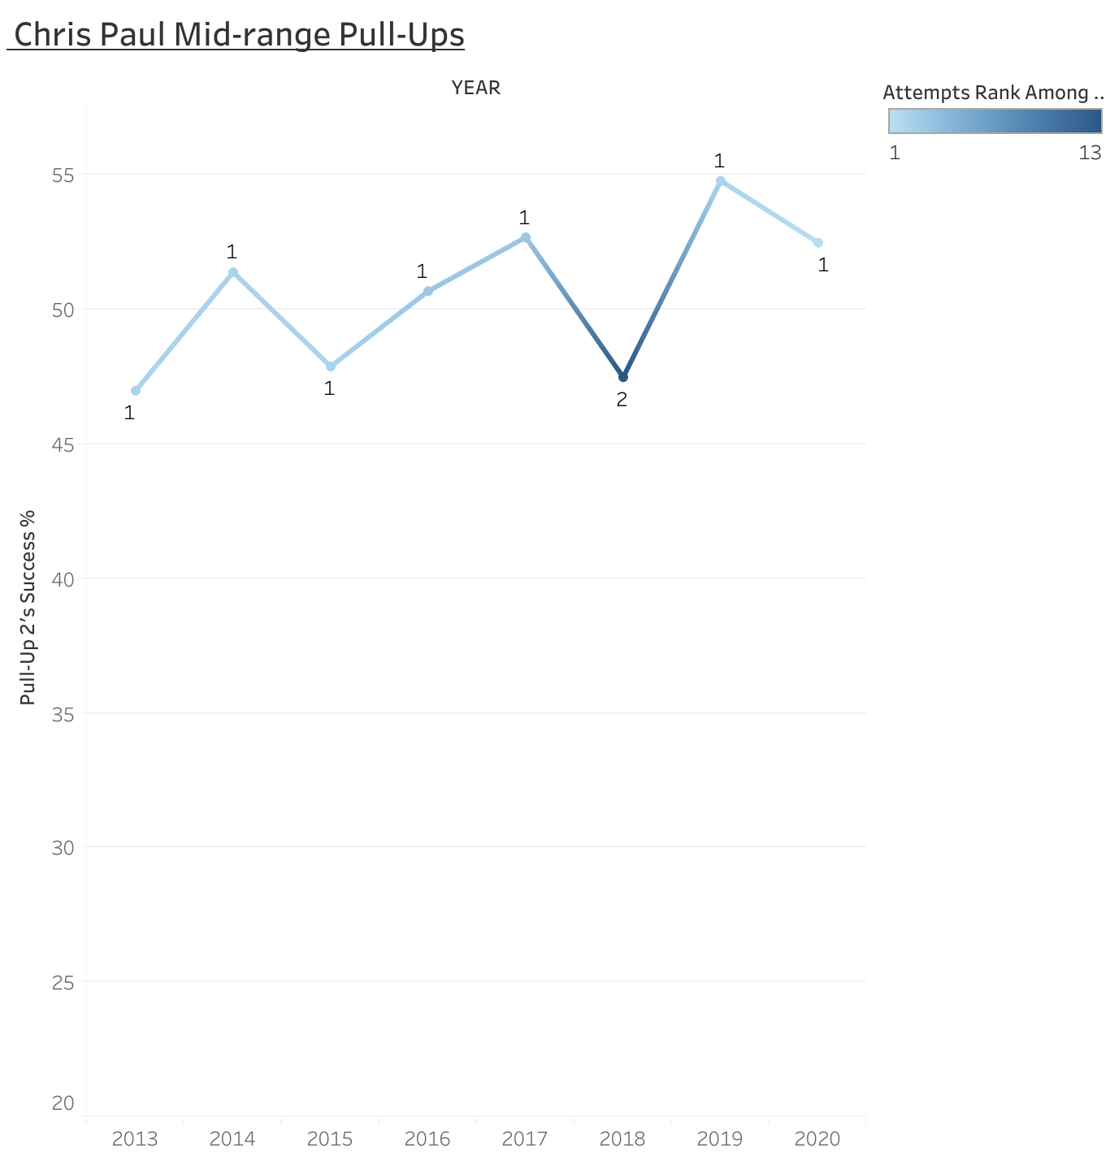

*The labels on each point refer to Paul’s ranking amongst all other point guards in mid-range shooting percentage*

The graph shows how Paul has maintained a monopoly over the mid-range shot. He consistently hovers around 50 percent success rate for these shots, ranking first among point guards in 7 of the last 8 years. The one year where Paul did not rank #1 was 2018, where he played along side James Harden who averaged 36 points per game. This particular season featured Paul playing off-ball than he ever had.

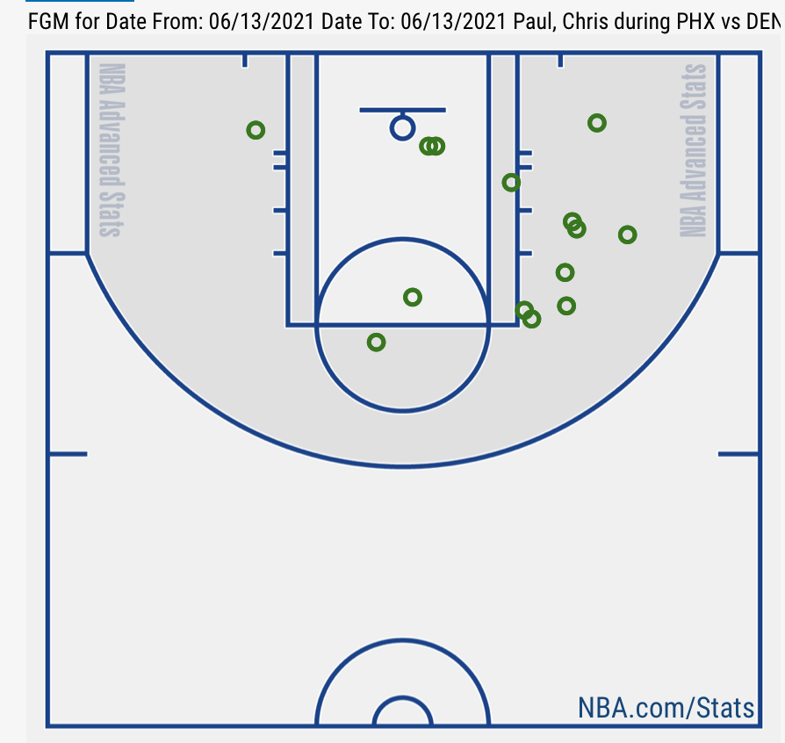

*Chris Paul’s made shots from game 4 of the Western Conference Semifinals versus the Denver Nuggets*

The shot chart above shows all of Paul’s made shots during Game 4 of the 2021 Conference Semifinals, where he put up 37 points. The mid-range area is marked up heavily on this chart, while there’s minimal activity at the rim and beyond the arc.

Paul’s mid-range mastery is a made possible due to two main factors:

1. His ability to get his teammates open three-pointers
2. His smart shot selection: only taking shots he’s comfortable with

Paul’s midrange prowess is set up by how he sets up his teammates at early stages in the game:

Here, Paul penetrates and gets to his favorite spot, the right elbow. When a Denver Nugget rotates towards him, he shovels the pass to his teammate on the three-point line. This essentially makes the defense respect his passing ability, so that his shot is available later in the game.

**first video** (drawn on)

Paul scored 25 of his 37 points in the second half:

*Video 2

The Nuggets’ players now are reluctant to leave the three-point line to stop Paul.

As CP3 drives in, The player guarding Mikal Bridges is intent on preventing a 3, leaving Paul’s favorite spot, the right elbow, wide open.



Paul’s passing ability (leading the NBA in assists this year with 10.1), opens up these shots that he is comfortable with. This is how Paul is able to impact the game 16 years in. The three-point revolution causes defenses to leave a sweet spot in the middle of the court, where Paul thrives.

*vid3

*Vid4 (drawn on)

Here, Paul uses his signature “snake dribble” around the screen and back to the right to get to his spot. CP3 is among the best at getting to his spot, a big part of his efficiency in the mid-range.

His next basket features the same maneuver:

*Video 5

The snake dribble is an example of how Paul is among the most proficient at securing the type of shot he wants on a given play.

This attribute is a rarity among other point guards that take similar volume of mid-range shots.

Here’s Russel Westbrook, the only other high volume point guard who attempts 2-point shots at a similar frequency to Paul in today’s game:

[Russell Westbrook's Shot Almost Misses Backboard 😬](https://www.youtube.com/watch?v=tGbTiDsa_IE)

Westbrook fails to employ any measures to get to a shot he is comfortable with, and settles for highly contested ones. This disparity in playing style is why Russell Westbrook has averaged 40 percent shooting on pull-up 2s over the last 10 years while Paul has averaged over 50 percent.

The reason that Suns guard Chris Paul has been able to stay effective for so long is because of his commitment to finding his midrange shot. These shots have opened up more as the rest of the league takes more threes, making Paul more valuable than ever.

Given that most point guards opt for the 3 over the 2 these days, how valuable is CP3’s midrange shooting compared to the biggest proponents of the three-pointer ? Let’s take a look at Chris’ 2021 shot chart compared to the consensus greatest shooter ever, Steph Curry.

**Chris Paul (Phoenix Suns) shot chart 2021 :**

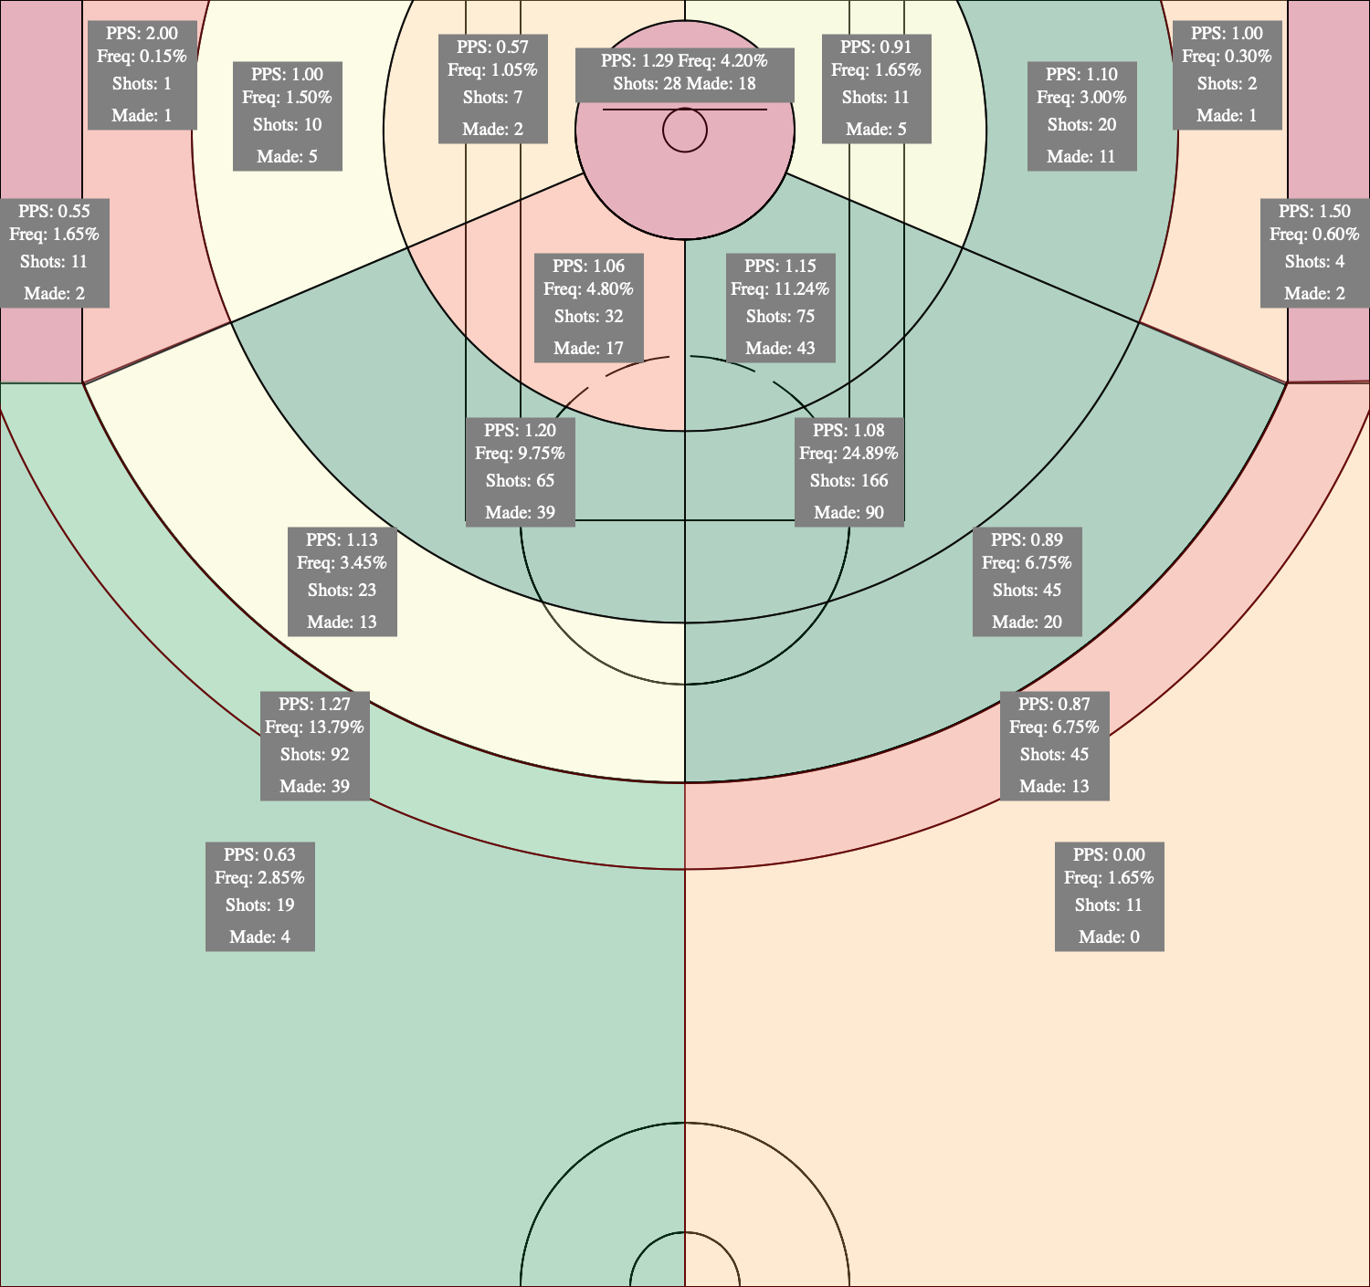

The green regions indicate high volume of shots taken. Contrast the color scheme with Curry’s shot chart:

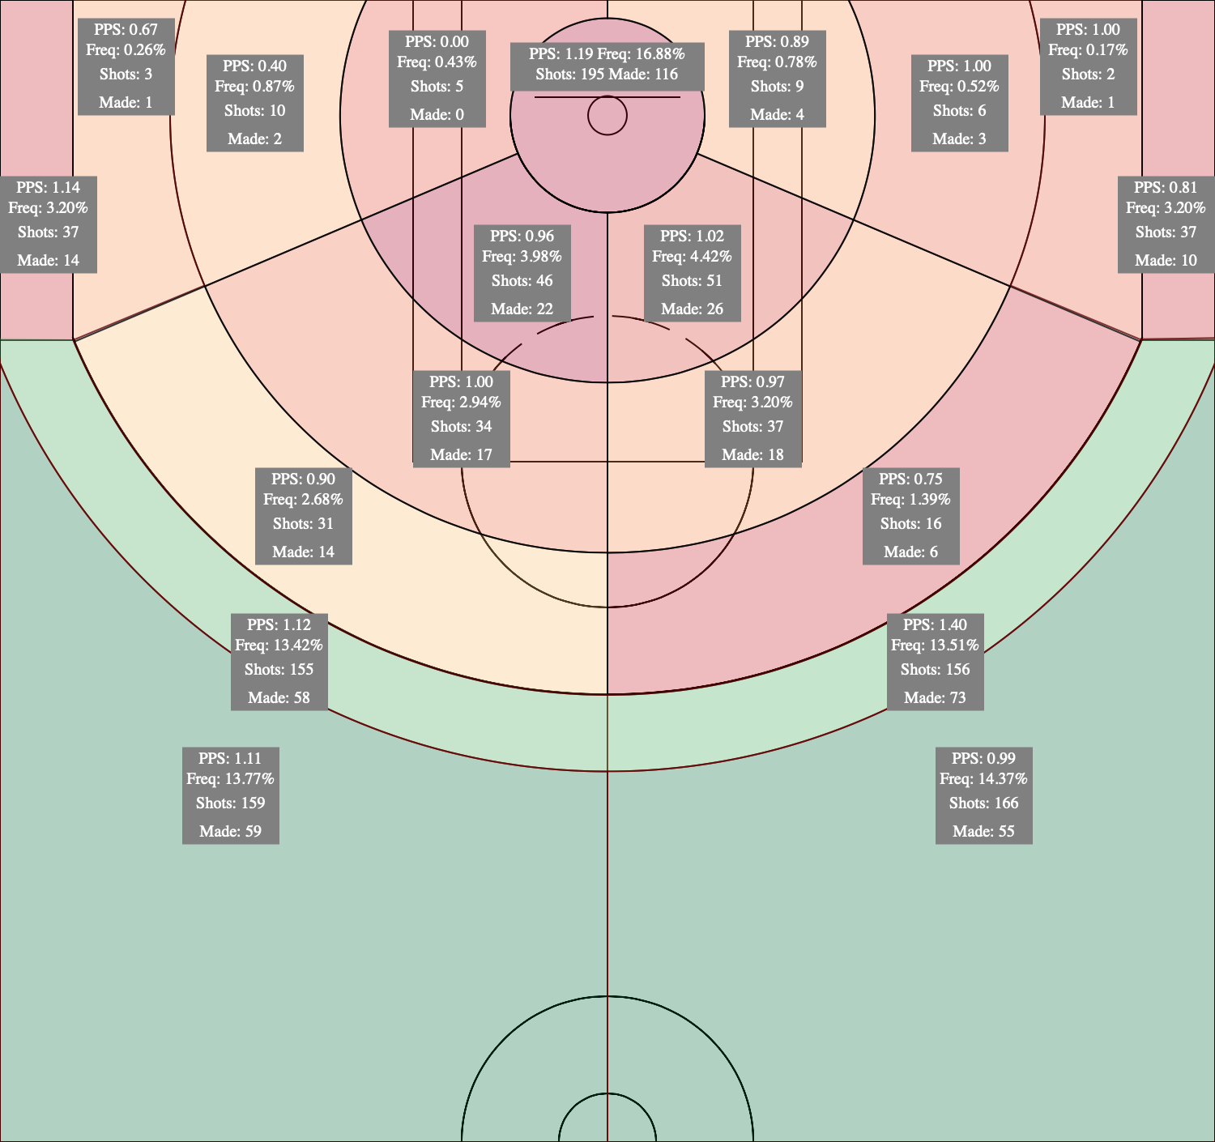

Curry’s chart and Paul’s charts are basically inverted. Paul’s green areas concentrate in the midrange while Curry’s green areas extend into deep range. Given these two disparate shot charts, we can gather data to determine which is more effective.

Although Curry’s three-point bombs have entailed the rest of the league following suit, Paul certainly seems to be an anamoly at the point guard position, defying the logic of analysts. From the information provided in these shot charts, Paul averages 1.09 points per shot in the mid-range area, while Curry averages 1.10 points per shot in three-point areas: nearly identical expected points.

This seems to contradict the crux of the argument for threes over twos. Overall, the analysts insist that the expected points yielded from a three-pointer are more than that of a two pointer. This may very well be true across the whole of the NBA, but there is something to be said about the fact that a preeminent three-point shooter such as Curry can have almost identical expected points to Paul’s mid-rangers this season. Now, conversely, Curry is having a down year by his standards, and Paul does shoot mid rangers better than any other point guard. This makes it difficult to generalize my findings by saying “all players should shoot midrange shots again now! No more threes!”. I’m not saying that much, but perhaps it is a sign of the pendulum being shifted back towards the rebirth of the two-pointer. Perhaps the defense moving out towards the three-point line to deal with shooters like Curry has made the mid-range shot an easier, better choice than it once was 10 years ago.

The NBA, like many other organizations, goes through phases and trends. Trends phase out and phase back in. In the 1990s, baggy clothes were in, and skinny jeans looked silly. Then in the 2010s, that trend reversed. Now, we see baggy clothes making a comeback! You probably know where I’m going with this. Maybe Chris Paul knows that in order to stay successful, he can’t change his basketball philosophy based on the “fashion trend” of the league. If the entire league wants to shoot threes, that makes his value increase rather than decrease, because his specialty has become a rarity in the current landscape. It’ll be interesting to see a potential Curry vs. Paul Western Conference Finals matchup this year, to see the two philosophies battle.